# **96-well Miniprep Protocol**

## Materials & Buffers

|  |  |  |
| --- | --- | --- |
| **Reagent / Buffer** | **Volume per Well** | **Notes** |
| **TB + Antibiotic** | 1.2 mL culture | Pre-warmed to 37 °C |
| **P1** (Resuspension) | 250 µL | Qiagen buffer + RNase A |
| **P2** (Lysis) | 250 µL | Alkaline lysis |
| **N3** (Neutralization) | 350 µL | Silica-binding enhancer |
| **PE** (Wash) | 750 µL × 2 | Ethanol wash buffer |
| **ddH₂O** (Elution) | 70 µL heated to 60 °C | Pre-heat to promote yield |

## 

## Equipment

* 2 mL square well deep-well 96-well plate (for growth & wash steps)
* 96-well lysate clearing plate (Epoch 2021F-002)
* 96-well silica binding plate (Epoch 2020-001)
* Swinging-bucket centrifuge (up to 5,000×g) with adapter for 96-well plates
* Multichannel pipettes & tip
* 60C water bath
* 96-well PCR plate

## 

## Workflow

### 1. Culture & Harvest

1. **Grow** cultures in 1.2 mL TB + antibiotic in each well (2 mL deep-well plate) overnight at 37 °C and 250 RPM.
2. These cultures are inoculated from the Addgene glycerol stocks.
3. **Pellet** cells: 5,000×g for 10 min (swinging-bucket).
4. Discard the supernatant without disturbing the pellet (flipping the plate should work if your spin speed was sufficient).

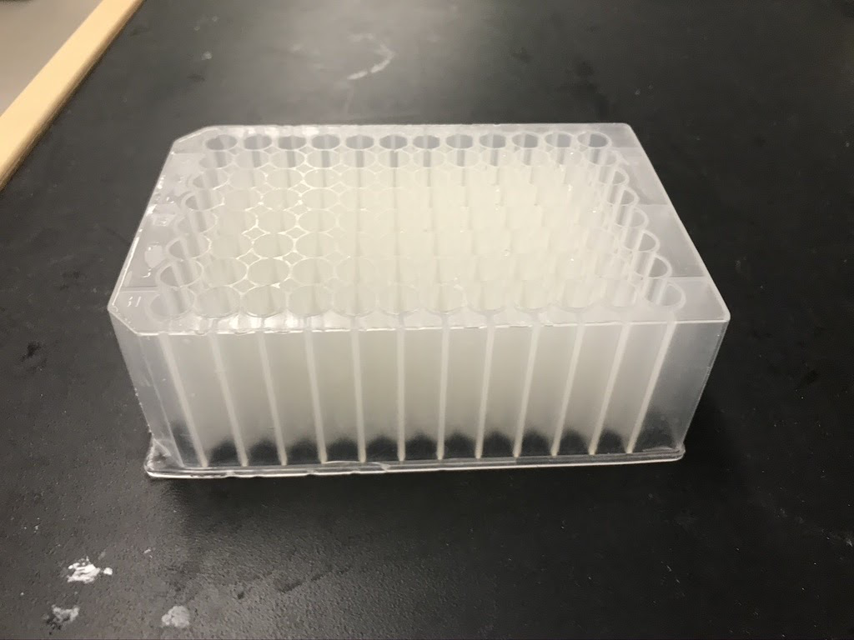

### 2. Lysis & Neutralization (use NEB miniprep buffers)

1. **Resuspend** pellet in **200 µL B1**, pipette up/down until no clumps remain.
2. **Lyse**: add **200 µL B2**, mix 6–8× by pipetting, incubate 2 min at room temp.
3. **Neutralize**: add **400 µL B3**, mix 6–8×, until solution looks uniform.

### 3. Lysate Clarification & Binding

1. **Clarify**
   * Spin at 5,000×g for 30 min (deep-well plate).
   * Transfer **only** the clear lysate to a 96-well lysate-clearing plate, and spin at 5,000×g for 5 minutes.

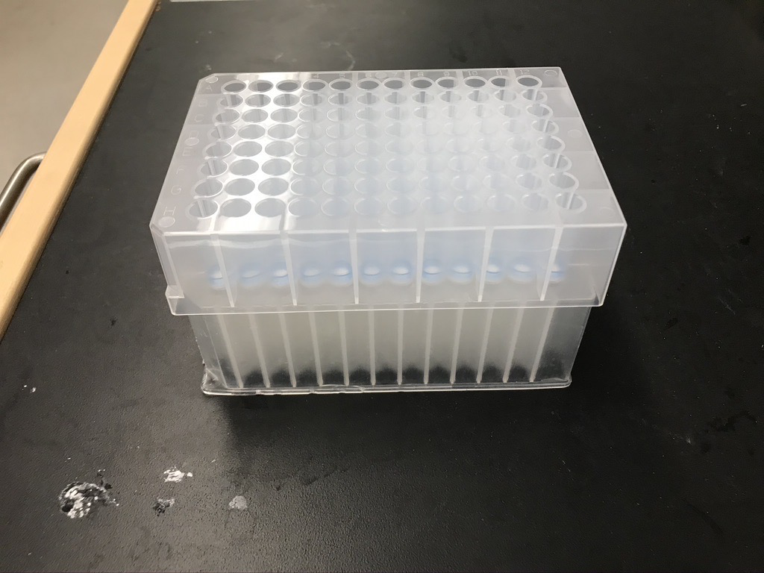

1. **Bind DNA**
   * Place binding plate on vacuum manifold (or spin adaptor).
   * Flow lysate through the binding plate—spin at 5,000xg for 5 minutes and collect flow-through in a waste plate.

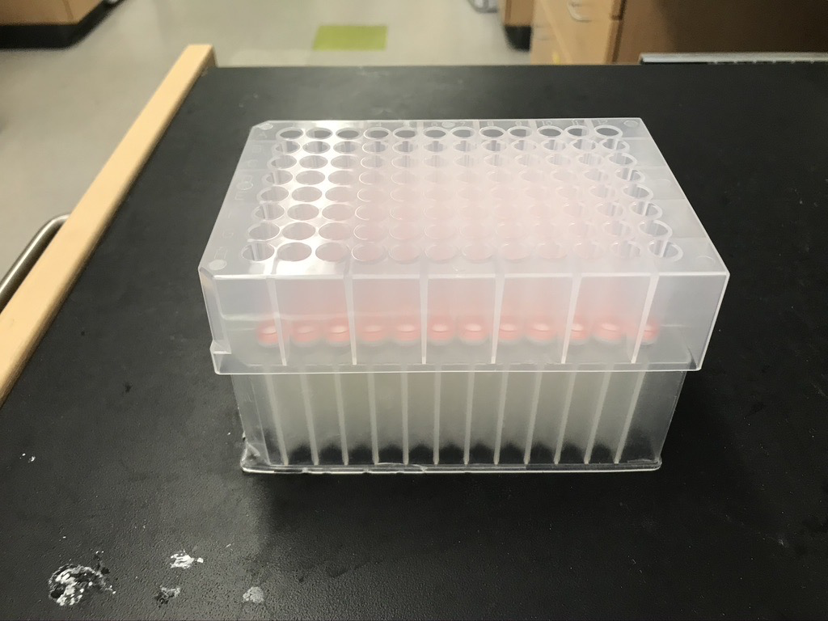

### 4. Wash & Dry

1. **Wash × 2**
   * Wash with **200 µL Buffer BZ**
   * Wash with **400 µL Buffer WZ**
2. **Dry spin**
   * Centrifuge for 5 min to remove residual ethanol.

### 5. Elution & QC

1. **Elute**
   * Warm **ddH₂O to 60 °C**, then add **70 µL** to each well, wait 5 min.
   * Spin at 5,000×g for 5 min into a fresh 96-well PCR plate.

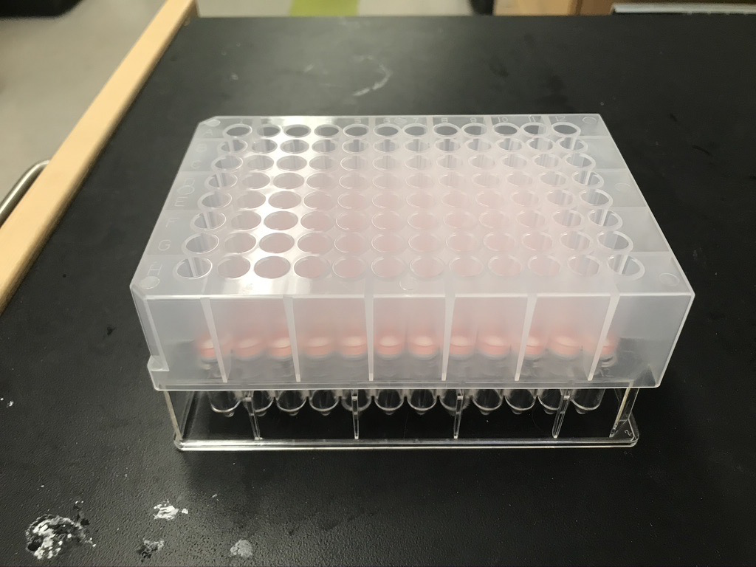

1. **Quantify** DNA (e.g., UV/fluorescence).
   * You can use the SpectraMax Quant AccuClear Nano dsDNA Assay Kit. Find a protocol [here](https://www.moleculardevices.com/sites/default/files/en/assets/product-insert/reagents/spectramax-quant-accuclear-nano-dsdna-assay-kits.pdf).
2. **Store** at -20 °C until ready for downstream assemblies.

## Tips for Success

* **Pipette consistency**: always use a multichannel and keep tips at a uniform depth.
* **Balance troubleshooting**: when spinning empty wells, add dummy weights (e.g., unused tips) to keep the rotor balanced.
* **Prevent clogging**: if lysate clogs a column, brief spin-down of the binding plate will clear debris—just repeat vacuum.
* **Scale & iterate**: once this runs smoothly, you can automate timing (e.g., robotics-friendly pauses) or swap in alternative lysis chemistries for higher-yield strains.